**DBMS ASSIGNMENT 1**

**TITLE:ONLINE ASSESSMENT PLATFORM**

**ABSTRACT:**

This project ONLINE ADAPTIVE ASSESSMENT PLATFROM, As a continous effort to improve and increase education system we implemented an online assessment server.its purpose is to ease the students examination process and to provide a transparent and object assessment.the application is developed using sql and javascript. Using admistration module,one can add or remove questions,question categories,can create test and set parameters in it. And immediately after exam this gives all details like no.of questions correct,wrong, total no.of questions, attended questions.after that examine_cell will examine the test details and give us the unique rank of particular student.and total score,then results will be released and student will be assessed to particular category they belongs to .

**Requirement analysis :**

THE BASIC OBJECTIVE OF ONLINE ADAPTIVE SYSTEM IS TO ANALYSE THE CATEGORY OF STUDENTS TO WHICH THE BELONGS TO BASED ON TEST CONDUCTED.

THE DATA BASE CONTAINS 4 ENTITIES . THEY ARE

1.STUDENTS-WHICH CONTAINS STUDENT DETAILS FOR ENROLLMENT TO EXAM

2.TEST-WHICH CONTAINS EXAM DETAILS

3.EXAMINE_CELL-WHICH ASSESS THE MARKS OF STUDENTS

4.RESULTS-WHICH GIVES THE RESULT TO STUDENTS

THE DATABASE CONSISTS OF 4 RELATIONSHIP SETS

THEY ARE:

REGISTERS:WHICH RESGISTER THE DETAILS

CHECKS : WHICH CHECKS THE TEST RESULT AND EXAMINES

GIVES:AFTER ASSESSMENT THIS GIVES THE

**list of attributes with their domain types:**

**student_s:**

sid: number(10)

sname: char(10)

email:varchar2(25)

phnnumber:number(10)

course:var(10)

**test:**

total_questions:number(10)

atemptted_questions:number(10)

correct_answers:number(10)

wrong_answer:

number(10)

tid:number(10)

**examine_cell**

sid:number

rank:number

total_score:number

medal_gained:char

**results:**

total_avg:number

category of student:varchar

sid:number

**ER DIAGRAM**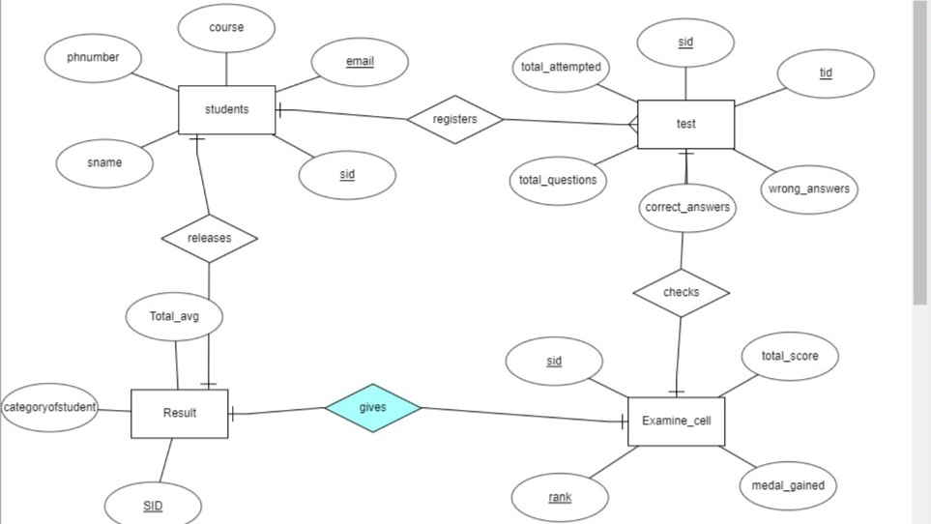

**MAPPING CARDINATES:**

STUDENTS TO TEST :MANY TO ONE

TEST TO EXAMINE_CELL:ONE TO ONE

EXAMINE_CELL TO RESULT:ONE TO ONE

RESULT TO STUDENTS: ONE TO ONE

**DDL COMMANDS:**

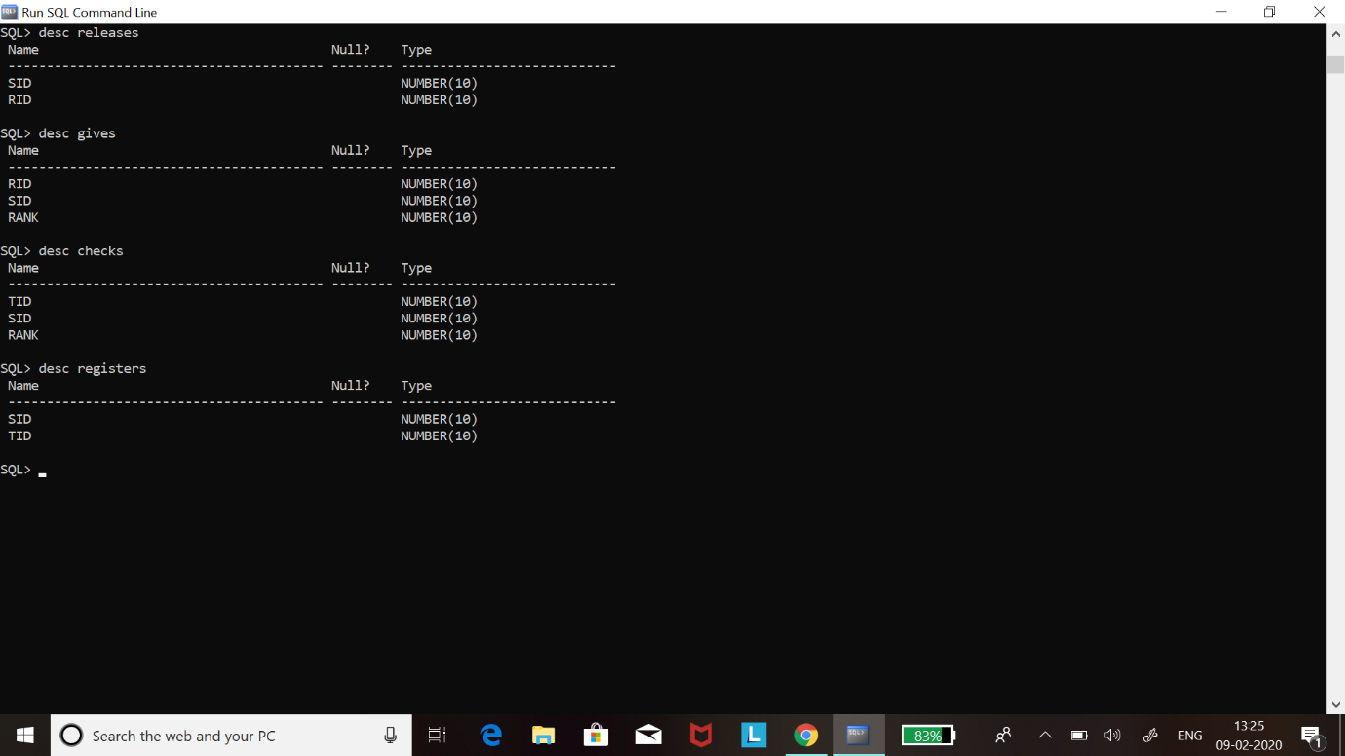

RELEASES:AFTER COMPLETING ALL THE STEPS THIS GIVES THE FINAL RESULTS T0 STUDENTS.

EXECUTION:

DML COMMANDS:

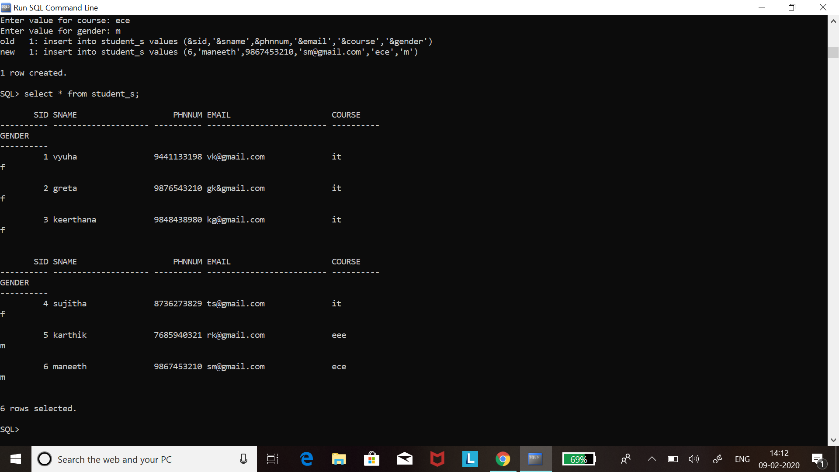

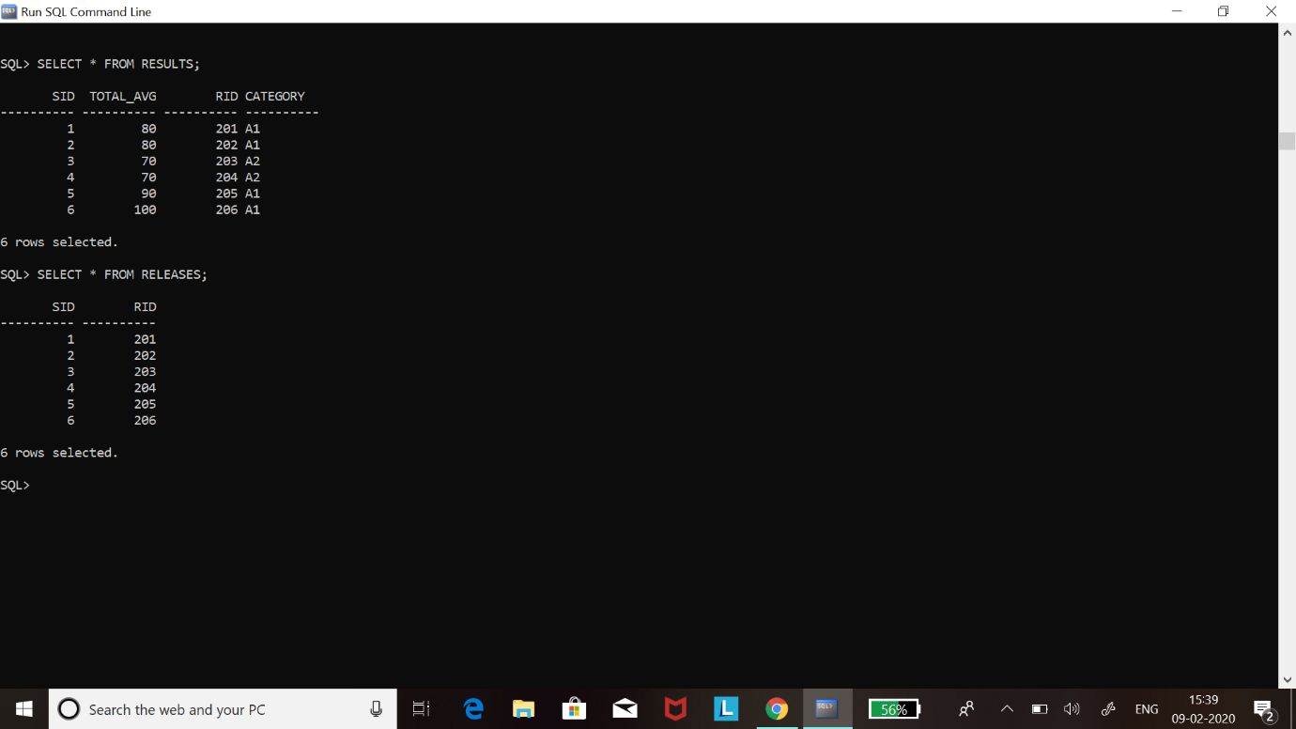

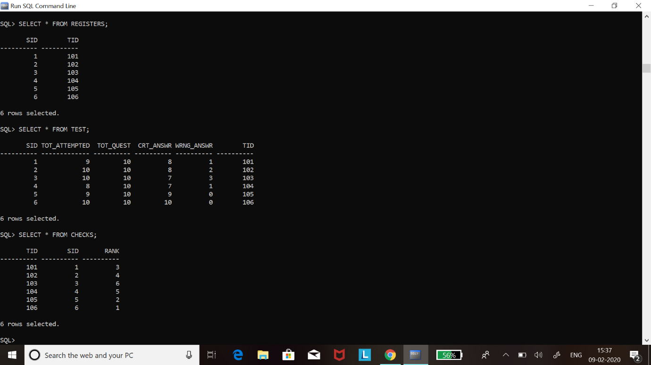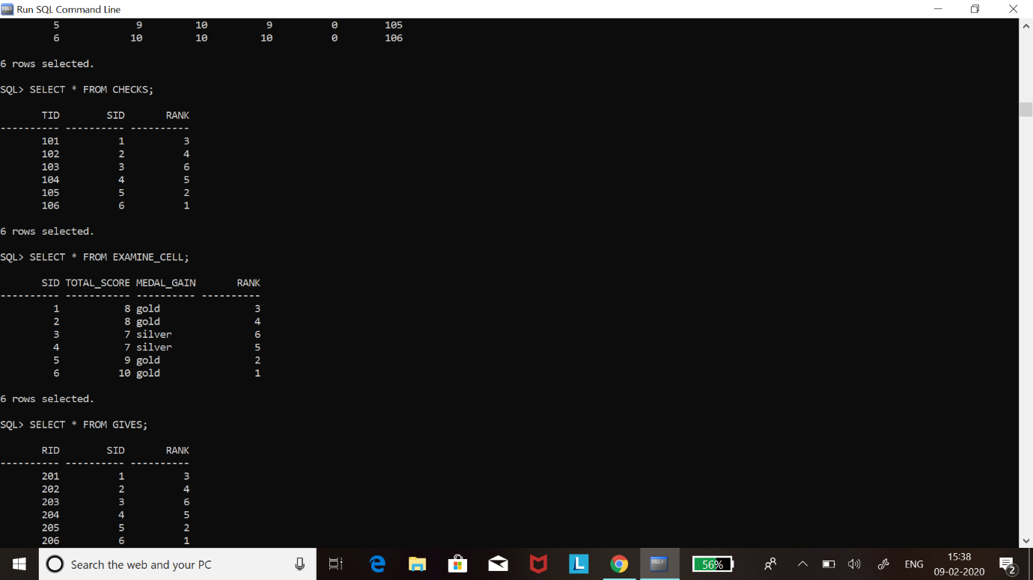

NAME:VYUHA KANDULA

ROLLNUM:1602-18-737-119

IT-B